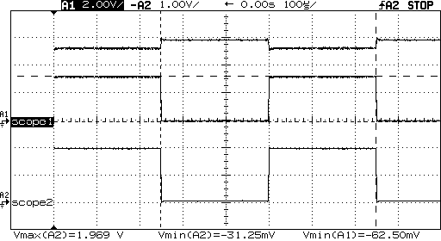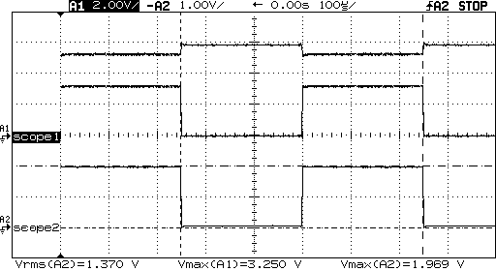

ON: V=3.250V-1.969V = 1.281 V I= 1.281/120 = 10.675 mA

OFF: V=-62.50mV-(-31.25mV) = -31.25mV I=-31.25mV/120 =-.260 mA